# CS 255 System Design Document Template

This template lays out all the different sections that you need to complete for Project Two. Each section has guidance to prompt your thinking. You will need to continually reference the interview transcript as you work to make sure that you are addressing your client’s needs. There is no required length for the final document. Instead the goal is to complete each section based on what your client’s needs are. Remove this note when you are finished, and replace all bracketed text with the relevant information.

## UML Diagrams

### UML Use Case Diagram

### UML Activity Diagrams

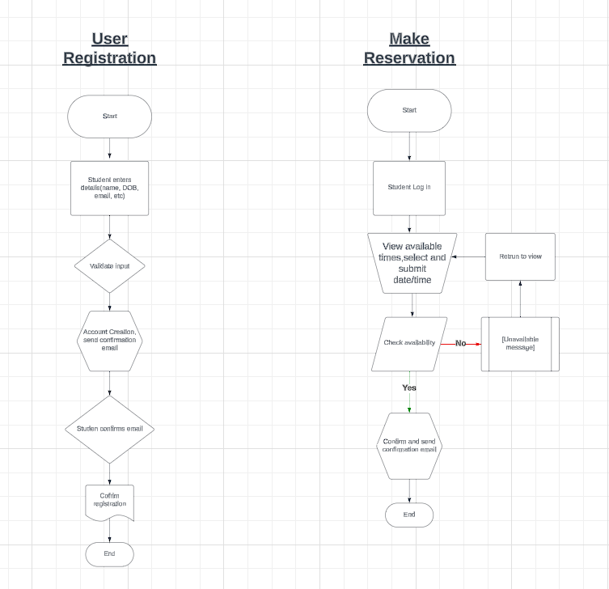

### UML Sequence Diagram

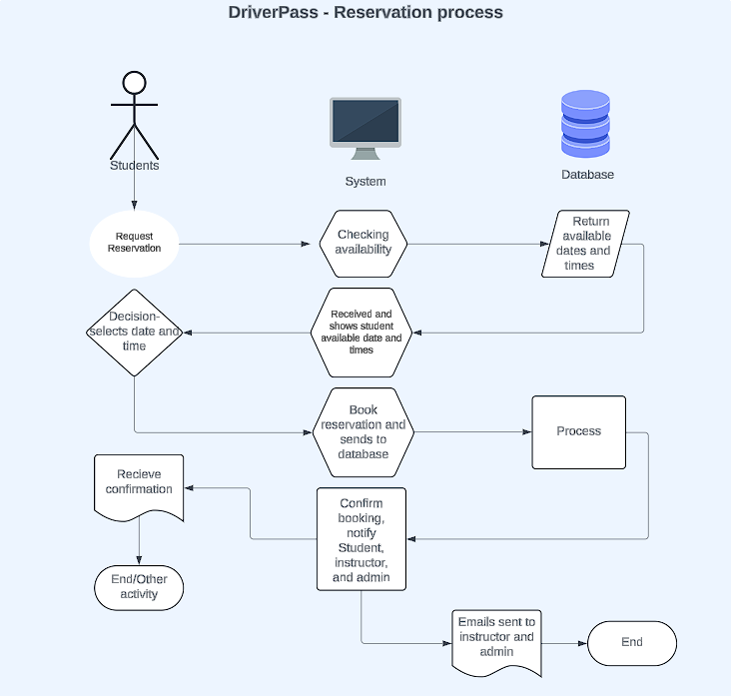

### UML Class Diagram

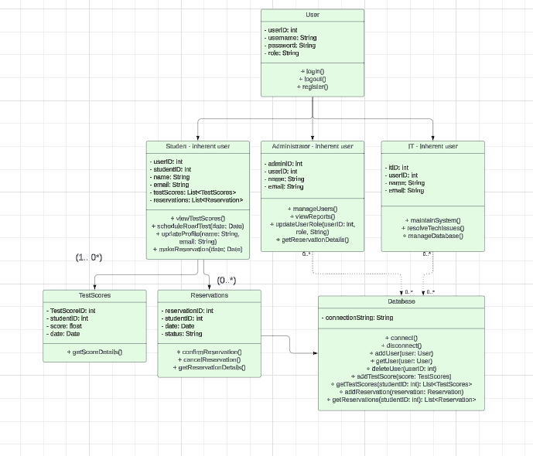

## Technical Requirements

DriverPass will require a combination of hardware, software and infrastructure to ensure performance and scalability. These requirements below provide a framework to support the application development and maintenance of this system to support the student, administration and IT officer of DriverPass.

**Hardware:**

**Server infrastructure:** A reliable server environment to host the database and web-based application. The system needs enough processing power and storage for user data and processing of such data.

**Client Devices:** Users’ access will be through desktops, laptops, and modern tablets through web browsers.

**Software:**

**Operating system:** Since the system is web based, all systems should be accessible from Windows, macOS, AndroidOS/iOS and any other system that has web browsing capabilities.

**Web Server:** Web hosting will be needed to manage the visualization that users see.

**Database:** A data storage to manage user information, test scores and reservations.

**Tools and Libraries:**

**Development:** A framework and libraries to streamline application development and enhance user interface designs.

**Authentication:** Security measures for managing user authentication and authorization. Security must be robust and meet DMV requirements.

**Testing:** Ensuring that the application is reliable and performs as necessary for all types of users (students, admin, IT)

**Monitoring and Maintenance:**

Monitoring tools: Track system performance and user activity

Logging solutions: Recording logs to assist in troubleshooting and debugging for IT officer.